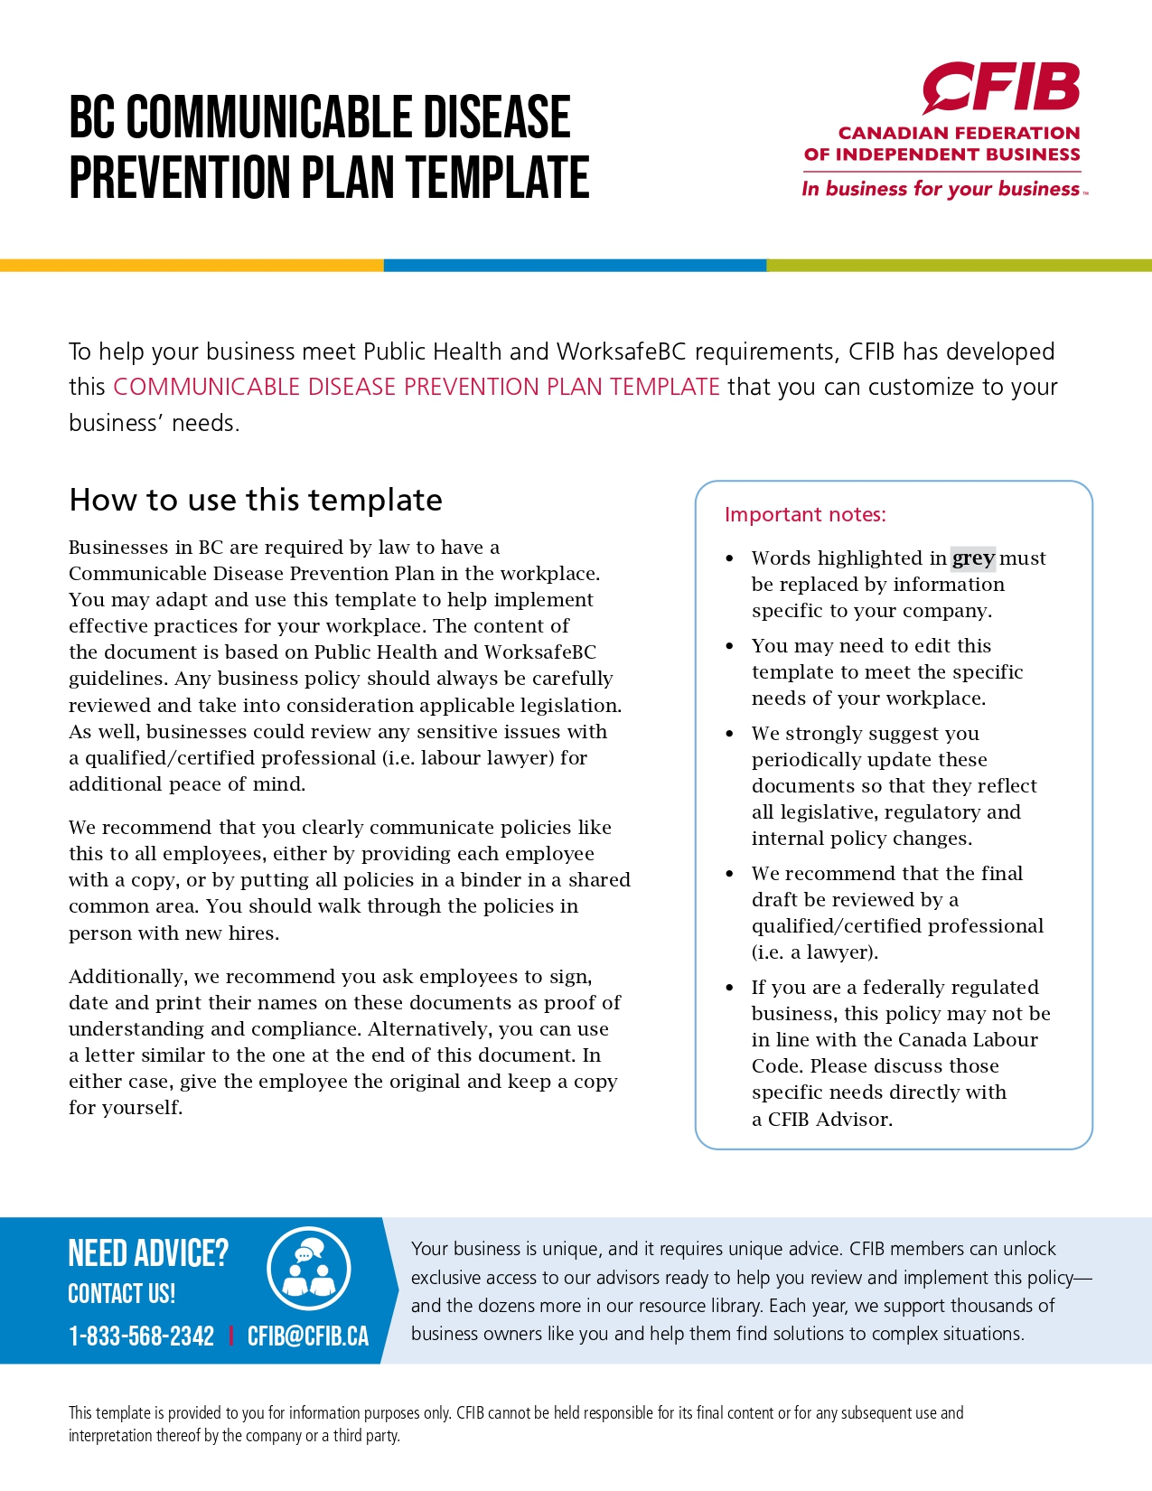
NAME OF BUSINESS’S COMMUNICABLE DISEASE PREVENTION PLAN

Purpose
The purpose of this policy is to outline the processes and procedures workers are expected to employ surrounding the prevention and management of communicable diseases, such as COVID-19 and SARS, in the workplace, and to outline the steps management will take to protect their safety.

Application
This policy applies to all workers (part time, full time, permanent, temporary, seasonal, employees, and sub-contractors) performing duties in and around name of business facilities and associated locations, at all times.

POLICIES & PROCEDURES

Prevention
Name of business’s number one priority is the health and safety of our employees and customers. We commit to taking every reasonable precaution to protect our employees and customers, and prevent the contraction and spread of communicable diseases, by:

- Managing a regular facility cleaning and disinfecting schedule of # times per day/week
- Maintaining a physical distance policy between fellow workers and customers of at least 2 metres at all times (where it does not negatively impact business operations)
- Erecting barriers between staff and customers (where it does not negatively impact business operations)
- Providing masks and hand sanitizer to staff and customers and promoting their use
- Posting signage reminding customers and staff of safety standards and procedures
- Promoting hygienic workplace practices, including but not limited to: handwashing, uniform/attire cleaning, etc.
- Promoting workers to use the Provincial Public Health Authority’s self-screening tool to perform a “self-check” before coming to work, and if they are not well, to communicate this with their manager/supervisor, and to stay home from work and take necessary steps to test and/or recover. Filling out a checklist is no longer required.

Management
Should a worker experience symptoms associated with a communicable disease, name of business commits to take the follow steps in support of our employees.

Employees shall adhere to these procedures:
- Immediately report these symptoms to their manager/supervisor.
- Leave the workplace and go directly home to self-isolate.
- The worker shall remain at home in a quarantine scenario until they follow up with their physician, and either receive a negative test result, or are symptom free for at least 24 consecutive hours.
- The company shall perform a thorough clean of the worker’s area, plus any spaces that the worker came into direct contact with.
- The company will closely monitor the health of employees who have come into direct contact with the worker, while maintaining each employee’s privacy and confidentiality to the utmost of our abilities.

Financial & Occupational Supports
- While the worker is in self-isolation and/or quarantine;
  - they will utilize name of business’s paid sick day plan;
  - they can request to utilize their vacation time/pay over this time;
  - they can take an unpaid leave of absence and access any current government sick day programs
  - if the virus was contracted at work, the employee may have access to WorkSafeBC benefits
- While the worker is experiencing symptoms, getting tested, or recovering from illness, their position is protected. Barring unforeseen circumstances, name of business will make every attempt possible to return the worker to the original position and duties they left, or as close of a position as possible that is available
- Emotional support may be obtained through open and honest discussion with your manager/supervisor at any time, the Provincial Public Health Authority Helpline, and through name of business’s Employee Assistance Program (EAP) with EAP provider name and phone number.

ADHERENCE – NAME OF BUSINESS’S COMMUNICABLE DISEASE PREVENTION PLAN

The employee understands that prevention and management of communicable diseases is the responsibility of all parties. Name of business pledges to do its part in preventing communicable diseases from entering and spreading in the workplace, but the employee must also take all reasonable precautions outside of work, in order to avoid being the source of a workplace illness. This includes avoiding situations where potential communication of the disease might occur (such as house parties, disease hot spots, etc.), as well as performing regular self-checks before coming to work, and if symptoms are being experienced, properly communicating this in a timely manner to the employee’s manager/supervisor. Failure to adhere to any of the terms, policies, and procedures identified in this document may result in disciplinary action, up to and including dismissal for cause.
All the policies of name of business are evolving documents that may be adapted as appropriate to reflect cultural and organizational changes as well as the modifications that are constantly being made to government regulations. We, at name of business, are committed to maintaining open and transparent communication with all employees and will provide updated policies (where applicable) in a timely manner.
Workplace health and safety is everyone’s responsibility. By signing below, the employee agrees to the terms and conditions of this policy and agrees to do their part in preventing the spread of communicable diseases in the workplace.

ACKNOWLEDGEMENT OF HAVING READ AND UNDERSTOOD THE COMMUNICABLE DISEASE PREVENTION PLAN
I, ____________, attest that I have read the Communicable Disease Prevention Plan and its various components.
I acknowledge having received all the relevant information that I need in order to have a good understanding of the content and scope of this policy.

Employee – Print Name
Employee – Signature |  | Date
Employer – Print Name
Employer – Signature |  | Date

